**MEDICAL DATA ANALYSER USING DATA VISUALIZATION**

**ABSTRACT**

In the modern healthcare landscape, the integration of advanced technologies such as Python programming, artificial intelligence (AI), presents a promising avenue for comprehensive medical data analysis, visualization, and predictive modelling. This paper proposes a methodology for utilizing these tools to enhance healthcare services, particularly in Medicare settings.

By leveraging Python, AI, healthcare providers can streamline the analysis of vast medical datasets, empowering them to extract actionable insights and make informed decisions. Through the normalization of medical data and the application of AI algorithms, predictive models can be trained to anticipate various medical conditions based on patient records. For instance, elevated blood glucose levels can be flagged as indicators of high blood sugar, enabling timely interventions and personalized treatment plans.

This approach holds immense potential for improving patient care and outcomes through proactive healthcare management. By enabling early detection and intervention, healthcare providers can effectively address medical issues before they escalate, thereby enhancing the quality of care and reducing healthcare costs. The proposed methodology not only enhances healthcare delivery within Medicare settings but also holds broader implications for healthcare systems worldwide.

|  |  |  |
| --- | --- | --- |
| **Table of Contents** | | |
| **Chapter No** | **Title** | **Page No** |
| 1 | Chapter 1 | 10 |
| 1.1 | Introduction | 10 |
| 1.2 | Problem Statement | 11 |
| 1.3 | Project Objectives | 12 |
| 2 | Chapter 2 | 13 |
| 2.1 | Literature survey | 13 |
| 3 | Chapter 3 | 14 |
| 3.1 | Methodology | 14 |
| 4 | Chapter 4 | 18 |
| 4.1 | Observation Done | 18 |
| 5 | Chapter 5 | 19 |
| 5.1 | Technology Used | 19 |
| 5.2 | Python Programming Language | 20 |
| 5.3 | Artificial Intelligence (AI) & Machine Learning (ML) Algorithms | 21 |
| 5.4 | Module Seaborn | 22 |
| 5.5 | Matplotlib for Medical Data Visualization | 23 |
| 5.6 | Pandas | 24 |
| 5.7 | Visual Studio for Efficient S/W Development in Medical Data Analysis | 25 |
| 5.8 | Jupyter Notebooks | 26 |
| 5.9 | Data Visualization Tools | 27 |
| 6 | Chapter 6 | 28 |
| 6.1 | Comparison with Existing Systems | 28 |
| 6.2 | Future Enhancement | 29 |
| 6.3 | Project Photos | 30 |
| 7 | Chapter 7 | 31 |
| 7.1 | Conclusion | 31 |
| 8 | Reference | 32 |

|  |  |  |
| --- | --- | --- |
| **List of Tables** | | |
| **Table No** | **Table Name** | **Page No** |
| 1 | Data Description | 15 |

|  |  |  |
| --- | --- | --- |
| **List of Figures** | | |
| **Figure No** | **Figure Name** | **Page No** |
| 1 | Cardio | 30 |
| 2 | Summary | 30 |

**CHAPTER 1**

***1.1 Introduction***

In today's healthcare landscape, integrating advanced technologies is vital for enhancing patient care and outcomes. Traditional methods of medical data analysis often face inefficiencies and limited predictive capabilities. However, Python programming, artificial intelligence (AI) offer a transformative opportunity. This project aims to revolutionize medical data analysis, visualization, and prediction, particularly within Medicare.

By harnessing Python, AI, healthcare providers can streamline analysis of complex medical datasets, extract actionable insights, and make informed decisions. Machine learning algorithms enable predictive models for early detection and intervention, such as identifying high blood sugar levels.

This project's significance lies in transforming healthcare delivery by providing data-driven insights and predictive capabilities to clinicians. Leveraging Python's versatility, AI's analytical power, computing resources, providers can enhance patient care, optimize resource allocation, and improve population health outcomes. Proactive healthcare management aims to reduce strain on systems and overall care costs.

The methodology presented here showcases the efficacy of leveraging Python, AI, in medical data analysis, visualization, and prediction. Through experiments, we demonstrate implications for healthcare delivery and patient management. Integration of these technologies holds immense promise for revolutionizing healthcare within Medicare and beyond.

1.2 ***Problem statement***

Healthcare systems encounter significant inefficiencies in data analysis and decision-making processes, primarily stemming from reliance on manual methods and constrained predictive capabilities. Manual data entry, preprocessing, and analysis are time-consuming, error-prone, and hinder timely interventions. Additionally, conventional approaches often lack the ability to anticipate and prevent adverse health events, resulting in reactive rather than proactive healthcare practices.

These limitations contribute to suboptimal patient outcomes, inefficient resource allocation, and increased healthcare costs. Addressing these challenges requires innovative solutions that harness the potential of advanced technologies such as Python, artificial intelligence (AI), and cloud computing. By leveraging these technologies, healthcare providers can streamline data analysis, enhance predictive capabilities, and ultimately improve healthcare delivery by enabling more personalized, proactive, and effective patient care.

The development of analytics for hospitals' healthcare data, optimized for data utilization, is crucial for achieving these goals, as it can significantly enhance patient care, streamline operations, and improve overall efficiency in healthcare institutions.

***1.3 Project Objectives***

An integrated analytics framework is proposed for hospitals to optimize data utilization, enhancing patient care, operational efficiency, and overall effectiveness. This framework entails designing and implementing data collection strategies to ensure completeness, accuracy, and relevance of healthcare datasets.

Advanced preprocessing techniques are employed to clean and standardize data, addressing issues like missing values and outliers. Machine learning algorithms and predictive models are utilized to identify patterns, trends, and factors impacting patient outcomes and resource allocation. Decision support systems are implemented to aid healthcare providers in making informed decisions and optimizing treatment plans. Rigorous testing and validation ensure the performance and effectiveness of the framework, with feedback from stakeholders incorporated to refine models and align with real-world workflows.

Scalable solutions are developed for seamless integration into existing systems, supported by comprehensive documentation, training, and user support. The impact of the framework is measured through quantifiable metrics, demonstrating improvements in patient outcomes, operational efficiency, and cost savings. Ultimately, the project aims to revolutionize healthcare delivery by leveraging data analytics to drive informed decision-making and enhance care delivery in hospitals and healthcare institutions.

**CHAPTER 2**

***2.1 Literature survey***

"Data Analytics in Healthcare: A Comprehensive Review" by Mittal and Kant (2018) provides an extensive overview of data analytics applications in healthcare, covering various topics such as data sources, analytics techniques, challenges, and future directions.

"Machine Learning for Healthcare: Review, Opportunities, and Challenges" by Rajkomar et al. (2018) offers a detailed examination of machine learning applications in healthcare, discussing opportunities, challenges, and ethical considerations associated with its implementation.

"Big Data Analytics in Healthcare: Promise and Potential" by Raghupathi and Raghupathi (2014) explores the promise and potential of big data analytics in healthcare, emphasizing its applications in disease prediction, personalized medicine, and healthcare management.

"Artificial Intelligence in Healthcare: Past, Present, and Future" by Hsiao et al. (2018) provides insights into the evolution of artificial intelligence in healthcare, discussing its past achievements, current applications, and prospects.

"Predictive Analytics in Healthcare: A Review of Current Trends and Applications" by Chae et al. (2018) examines current trends and applications of predictive analytics in healthcare, including disease prediction, risk stratification, and treatment optimization.

Additionally, several other resources contribute to the understanding of healthcare data analytics:

"Data Mining Techniques for Healthcare: A Review" by Bellazzi and Zupan (2008)

"Healthcare Data Analytics" edited by Reddy and Aggarwal (2015)

"Applications of Big Data Analytics in Healthcare: A Review" by Bhaskar et al. (2016)

"Challenges and Opportunities of Healthcare Big Data Analytics" by Kavakiotis et al. (2017)

"Machine Learning Techniques for Healthcare Data Analytics" by Kotsiantis et al. (2017)

These resources cover a range of topics including data mining techniques, predictive modeling, clinical decision support systems, challenges, opportunities, and ethical considerations associated with healthcare data analytics.

**CHAPTER 3**

***3.1 Methodology***

**MACHINE LEARNING**

* **Manage Data:**

Managing data is the crucial first step in any machine learning project. It involves a series of tasks that ensure the data used to train models is high quality and suitable for the intended purpose.

* (i) **Data Collection:**
* This involves gathering data relevant to the problem you're trying to solve. This could involve collecting data from various sources like databases, sensors, or web scraping. This data may include:
  + Demographics: Age, gender, ethnicity (potential risk factors)
  + Physiological Measurements: Weight, height, body mass index (BMI)
  + Blood Glucose Levels: Fasting blood sugar, HbA1c levels
  + Medical History: Presence of related conditions (e.g., hypertension)
  + Family History: Family members diagnosed with diabetes (potential genetic predisposition)
* **Data Preprocessing:**

Cleanse data for missing values, outliers, and inconsistencies. Perform transformation, standardization, and normalization for consistency.

**Data Description:**

| **Feature** | **Variable Type** | **Variable** | **Value Type** |
| --- | --- | --- | --- |
| Age | Objective Feature | age | int (days) |
| Height | Objective Feature | height | int (cm) |
| Weight | Objective Feature | weight | float (kg) |
| Gender | Objective Feature | gender | categorical code |
| Systolic blood pressure | Examination Feature | ap_hi | int |
| Diastolic blood pressure | Examination Feature | ap_lo | int |
| Cholesterol | Examination Feature | cholesterol | 1: normal, 2: above normal, 3: well above normal |
| Glucose | Examination Feature | gluc | 1: normal, 2: above normal, 3: well above normal |
| Smoking | Subjective Feature | smoke | binary |
| Alcohol intake | Subjective Feature | alco | binary |
| Physical activity | Subjective Feature | active | binary |
| Presence or absence of cardiovascular disease | Target Variable | cardio | binary |

(ii) **Data Explore:** Data exploration involves analyzing the characteristics of your data to understand its distribution, identify missing values or outliers, and uncover potential relationships between features.

(iii) **Data Cleanse:** Real-world data often contains inconsistencies, missing values, and errors. Data cleaning addresses these issues to ensure the model is trained on accurate and reliable information.

(iv) **Data Prepare:** This stage often involves transforming the data into a format suitable for machine learning algorithms. This might include normalization, scaling, and feature engineering.

(v) **Data Split:**In machine learning, data is typically split into training and testing sets: the training set educates the model, while the unseen testing set evaluates its generalizability.

* **Train Modals:** Training models in machine learning involves feeding the prepared data into chosen algorithms. These algorithms learn from the patterns within the data, allowing them to make predictions on new, unseen data. This process often involves adjusting internal parameters (hyperparameters) to optimize the model's performance.
* **Evaluate Models:** Evaluating models is critical to assess their performance and identify the best option for the task. This involves using metrics like accuracy, precision, and recall on a separate testing set to measure the model's ability to make accurate predictions on unseen data.

(i) **Accuracy:** This metric reflects the overall correctness of the predictions. It simply calculates the percentage of instances where the model's predictions match the actual outcomes.

(ii) **Precision:** This metric focuses on the **positives** the model predicted correctly. It tells you what proportion of the instances the model labeled as positive actually turned out to be positive.

(iii) **Recall:** This metric emphasizes the **completeness** of the model's positive predictions. It represents the proportion of actual positive cases the model was able to correctly identify.

* **Deploy Model: Deploying a machine learning model involves making it operational** for real-world use. This entails packaging the trained model, integrating it with a web service or application, and deploying it on a suitable infrastructure (cloud platform or on-premises servers) to handle incoming data and generate predictions. By analyzing the user's clinical data through these machine learning models, the system generates a risk score and provides valuable preliminary assessment, which can be further refined through further analysis for high-risk individuals.
* **Documentation and Reporting**:

Document methodology, including data collection, preprocessing, model development, and deployment. Prepare comprehensive reports and presentations to communicate findings and recommendations to stakeholders and healthcare professionals.

**CHAPTER 4**

***4.1 Observation Done***

***Data Distribution and Characteristics:***

Analyzed healthcare datasets to unveil variations in data distributions and central tendencies, illuminating insights into patient demographics, medical history, and treatment outcomes.

***Correlation Analysis:***

Explored correlations among patient demographics, medical conditions, treatment interventions, and healthcare outcomes to uncover patterns and associations within the healthcare data.

***Outlier Detection:***

Detected outliers within the healthcare data using statistical techniques and visualization methods.Investigated potential reasons for outliers and assessed their impact on data analysis and modeling processes.

***Feature Importance:***

Conducted feature importance analysis to identify key predictors of patient outcomes, operational performance, and other relevant metrics. Ranked features based on their predictive power and relevance to the project objectives, informing subsequent modeling and decision-making processes.

***Model Performance Evaluation:***

Evaluated the performance of predictive models using appropriate metrics such as accuracy, precision, recall, and F1-score. Assessed the robustness and generalization of models through cross-validation techniques, ensuring their suitability for deployment in real-world healthcare settings.

***Predictive Insights:***

Generated predictive insights based on the analysis of healthcare data, identifying potential risk factors recommendations. Leveraged predictive models to forecast patient outcomes, optimize treatment strategies, and inform clinical decision-making processes.

***Validation and Interpretation:***

Validated predictive insights and model predictions through comparison with ground truth data and feedback from domain experts. Interpreted findings and recommendations in the context of clinical guidelines, best practices, and healthcare policies to ensure their relevance and applicability.

**CHAPTER 5**

***5.1 Technology Used***

In today's data-driven world, the integration of advanced technologies has revolutionized the landscape of data analysis and visualization. Python, AIML (Artificial Intelligence Markup Language), Seaborn, Matplotlib, Pandas, Jupyter Notebook, Visual Studio Code, and data visualization techniques collectively form a powerful arsenal for exploring, analyzing, and presenting data effectively.

Python, a versatile and user-friendly programming language, serves as the backbone for various data analysis tasks. Its extensive libraries, including Pandas for data manipulation and Seaborn/Matplotlib for visualization, provide robust tools for handling and visualizing datasets. AIML, on the other hand, extends Python's capabilities by incorporating artificial intelligence techniques for data processing and pattern recognition, enabling more sophisticated analyses.

In the realm of data visualization, Seaborn and Matplotlib offer rich visualization capabilities, allowing users to create insightful plots, charts, and graphs to convey complex information intuitively. These libraries, coupled with Pandas' data manipulation capabilities, facilitate the exploration and interpretation of datasets with ease.

Jupyter Notebook serves as an interactive computing environment, allowing users to create and share documents containing live code, equations, visualizations, and narrative text. Its integration with Python and other technologies makes it a popular choice for data analysis and exploration tasks.

Visual Studio Code, a powerful code editor, provides a seamless development experience for Python programming and data analysis tasks. Its robust features, including syntax highlighting, debugging capabilities, and extensions for Python and data science, enhance productivity and streamline development workflows.

Overall, the combination of Python, AIML, Seaborn, Matplotlib, Pandas, Jupyter Notebook, Visual Studio Code, and data visualization techniques offers a comprehensive toolkit for data analysts, scientists, and researchers to uncover insights, derive meaningful conclusions, and communicate findings effectively. In this document, we will explore the capabilities of these technologies and demonstrate their practical applications in various data analysis and visualization scenarios.

***5.2 Python Programming Language***

* Python's simplicity, versatility, and rich ecosystem of libraries such as Pandas and Matplotlib make it ideal for medical data analysis and prediction.
* In the context of our project, Python offers several advantages:

***Ease of Use:***

Python's clean and readable syntax makes it accessible to both beginners and experienced programmers. This simplicity allows healthcare professionals with varying levels of coding experience to participate in medical data analysis and prediction tasks.

***Rich Ecosystem:***

Python boasts a vast ecosystem of libraries and frameworks specifically tailored for data analysis, machine learning, and artificial intelligence. Libraries such as Pandas, NumPy, and sci-kit-learn provide powerful tools for data manipulation, preprocessing, and modeling, streamlining the process of analyzing complex medical datasets.

***Machine Learning Capabilities:***

Python is widely used in machine learning and predictive analytics, making it well-suited for developing predictive models for medical data analysis. With libraries like sci-kit-learn, TensorFlow, and Keras, we can easily implement machine learning algorithms to predict patient outcomes, diagnose diseases, and optimize treatment plans based on medical data.

***Visualization Tools:***

Python offers powerful visualization libraries such as Matplotlib, Seaborn, and Plotly, enabling us to create insightful visualizations of medical data trends, patterns, and predictions. Visualizations play a crucial role in understanding complex medical datasets and communicating findings to healthcare professionals and stakeholders effectively.

***5.3 Artificial Intelligence (AI) and Machine Learning (ML) Algorithms***

* Utilized AI and ML techniques, including regression, classification, and clustering, to develop predictive models and glean insights from healthcare data, transforming healthcare through advanced analysis and decision support systems.
* In the context of our project, AI and ML offer several benefits:

***Predictive Analytics:***

AI and ML algorithms harness vast medical datasets to uncover nuanced patterns and predictive features overlooked by traditional statistics, enabling the development of models that forecast patient outcomes, detect diseases early, and suggest personalized treatment plans tailored to individual patient characteristics and medical history.

***Clinical Decision Support:***

ML algorithms can act as intelligent assistants to healthcare professionals by providing real-time insights and recommendations for clinical decision-making. These decision support systems can help clinicians interpret medical data, prioritize patient care tasks, and optimize treatment strategies, ultimately leading to more accurate diagnoses and improved patient outcomes.

***Personalized Medicine:***

AI and ML enable the concept of personalized medicine, where treatment plans are tailored to the unique characteristics and needs of each patient. By analyzing genetic, clinical, and demographic data, ML models can predict individual responses to different treatments and interventions, allowing for more targeted and effective healthcare delivery.

***Healthcare Operations Optimization:***

AI and ML streamline healthcare operations, optimizing resource allocation and workflow efficiency, while predictive analytics models forecast patient demand and identify process improvements, yielding cost savings and enhanced resource utilization.

**5.4 Module Seaborn**

* Seaborn is a powerful Python visualization library built on top of Matplotlib, offering a high-level interface for creating attractive and informative statistical graphics.
* In the context of our project on medical data analysis and prediction, Seaborn offers several benefits:

**Statistical Data Visualization:**

Seaborn specializes in creating statistical visualizations that provide insights into complex datasets. With Seaborn, we can easily generate informative plots such as histograms, scatter plots, box plots, and violin plots to explore the distribution and relationships between medical variables.

**Beautiful Aesthetics and Default Styles**:

Seaborn comes with beautiful default styles and color palettes that enhance the aesthetics of our visualizations. The default styles are designed to be visually appealing and easily customizable, allowing us to create professional-looking plots with minimal effort.

**Regression Analysis and Plotting:**

Seaborn provides built-in support for regression analysis and plotting, allowing us to visualize linear and nonlinear relationships between medical variables. With functions such as lmplot and regplot, we can fit regression models to our data, visualize the regression lines, and assess the goodness of fit of the models.

**Integration with Pandas DataFrames:**

Seaborn seamlessly integrates with Pandas DataFrames, making it easy to visualize data stored in tabular format. By leveraging Seaborn's plotting functions directly on Pandas DataFrames, we can streamline our data visualization workflow and create insightful visualizations with minimal code.

***5.4 Matplotlib for Medical Data Visualization***

* Matplotlib is a powerful Python library for creating static, animated, and interactive visualizations of data.
* In the context of our project on medical data analysis and prediction, Matplotlib offers several benefits:

***Flexible Visualization Options:***

Matplotlib offers diverse plotting functions and customization options.

It enables the creation of various visualizations tailored to specific medical data needs.

***Publication-Quality Figures:***

Matplotlib produces professional-quality figures suitable for scientific papers and presentations.

Customizable styles, fonts, colors, and annotations enhance communication of analysis findings.

***Interactive Visualization with Jupyter Notebooks:***

Seamless integration with Jupyter Notebooks enables interactive exploration of medical datasets.

Embedding Matplotlib plots facilitates dynamic adjustment of parameters for deeper insights.

***Integration with Data Analysis Pipelines:***

Matplotlib integrates seamlessly with Pandas, NumPy, and sci-kit-learn.

This streamlines data analysis workflows, facilitating end-to-end solutions for medical data processing, modeling, and visualization.

***Support for Advanced Plot Types:***

Matplotlib supports advanced plot types like box plots, violin plots, contour plots, and 3D surface plots.

These are particularly useful for visualizing distributions of clinical measurements and complex relationships in medical datasets.

***5.6 Pandas***

* Pandas is a powerful Python library for data manipulation and analysis, particularly well-suited for our project on medical data analysis and prediction.
* Here are some key aspects of Pandas and its relevance to our project:

***Data Structures for Tabular Data:***

Pandas provides two main data structures, Series and DataFrame, which are highly efficient for handling tabular data. These data structures allow us to represent medical datasets in a structured format with rows and columns, making it easy to perform various data manipulation and analysis tasks.

***Data Loading and Cleaning:***

Pandas offers robust tools for loading data from various sources, including CSV files, Excel spreadsheets, SQL databases, and more. Once loaded, Pandas provides powerful methods for cleaning and preprocessing medical datasets, including handling missing values, removing duplicates, and standardizing data formats.

***Data Manipulation and Transformation:***

Pandas offers a wide range of functions and methods for manipulating and transforming medical datasets. We can perform operations such as filtering rows, selecting columns, grouping data, aggregating statistics, and creating new derived variables based on existing data.

***Integration with Visualization Libraries:***

Pandas seamlessly integrate with visualization libraries such as Matplotlib and Seaborn, allowing us to create informative plots and visualizations directly from Pandas data structures. By combining Pandas with these visualization tools, we can gain insights into medical datasets and communicate our findings effectively through visualizations.

***Efficient Data Handling for Machine Learning:***

Pandas play a crucial role in preparing medical datasets for machine-learning tasks such as predictive modeling and classification. We can use Pandas to preprocess features, handle categorical variables, encode labels, and split data into training and testing sets, streamlining the machine learning pipeline.

***5.7 Visual Studio for Efficient Software Development in Medical Data Analysis***

* Visual Studio (VS) is a comprehensive integrated development environment (IDE) provided by Microsoft, offering a suite of powerful tools and features for software development.
* In the context of our project on medical data analysis and prediction, Visual Studio offers several benefits:

***Support for Multiple Programming Languages:***

Visual Studio supports a wide range of programming languages commonly used in data analysis and machine learning, including Python, R, and C#. This flexibility allows us to choose the most suitable language for our project requirements and seamlessly switch between languages as needed.

***Advanced Code Editing and Debugging Tools:***

Visual Studio offers advanced code editing and debugging tools that facilitate software development in medical data analysis. Features such as IntelliSense, code refactoring, and real-time debugging help improve code quality, reduce errors, and speed up development iterations.

***Collaborative Development and Version Control:***

Visual Studio supports collaborative development workflows and version control systems such as Git, enabling multiple developers to work on the same codebase simultaneously. This facilitates teamwork, knowledge sharing, and code review processes, ensuring the quality and integrity of our project codebase.

***5.8 Jupyter Notebooks***

* Used for interactive coding, documentation, and presentation of project workflows and results.Enabled integration of code, text, and visualizations for effective communication and collaboration. Jupyter Notebooks are a powerful tool for interactive computing and data analysis, particularly well-suited for our project on medical data analysis and prediction.
* Here are some key aspects of Jupyter Notebooks and their relevance to our project:

***Interactive Computing Environment:***

Jupyter Notebooks provides an interactive computing environment that allows us to write and execute Python code in a structured and flexible manner. This interactive nature enables us to explore medical datasets, perform data analysis, and develop predictive models in an iterative and exploratory fashion.

***Code, Text, and Visualizations in One Document:***

Jupyter Notebooks combine code, text, and visualizations in a single document, making it easy to document our analysis workflows, explain our methodology, and communicate our findings to collaborators and stakeholders. This seamless integration of code and narrative enhances reproducibility and transparency in our project.

***Real-time Data Exploration and Visualization:***

With Jupyter Notebooks, we can interactively explore and visualize medical data in real time using Python libraries such as Pandas, Matplotlib, and Seaborn. This allows us to gain insights into the underlying patterns and trends within the data, identify potential predictive features, and evaluate the performance of our predictive models.

***Collaborative Development and Sharing:***

Jupyter Notebooks enable simultaneous collaborative development, fostering teamwork and knowledge exchange among project collaborators, while facilitating easy sharing via email, GitHub, or JupyterHub for seamless collaboration with external partners and stakeholders.

***5.9 Data Visualization Tools***

* Matplotlib, Seaborn, and other visualization libraries enhance medical data analysis and prediction by creating insightful visualizations, aiding in understanding data patterns, trends, and model evaluation results.
* Here are some key aspects of data visualization and its relevance to our project:

***Exploratory Data Analysis (EDA):***

Data visualization techniques allow us to explore and understand the underlying patterns and relationships within medical datasets. By visualizing variables such as patient demographics, medical history, and treatment outcomes, we can identify trends, outliers, and potential predictive features that may influence patient outcomes.

***Insight Generation:***

Visualizations help us generate actionable insights from medical data by highlighting important trends and patterns. For example, we can use scatter plots to visualize the relationship between patient age and disease severity, or histograms to analyze the distribution of blood glucose levels among diabetic patients. These insights can inform clinical decision-making and treatment strategies.

***Identification of Trends and Anomalies:***

Data visualization techniques such as time series plots and heatmaps enable us to identify temporal trends and anomalies in medical data. For example, we can visualize changes in disease prevalence over time or detect sudden spikes inpatient admissions to emergency departments. These insights can help healthcare providers anticipate and respond to emerging health threats more effectively.

**CHAPTER 6**

***6.1 Comparison with Existing Systems***

Traditional tests, while established, are invasive and may discourage frequent monitoring. Existing ML-based systems offer a non-invasive option but can have limitations in accuracy.

The proposed two-stage system addresses these shortcomings. It leverages machine learning for comprehensive risk assessment (Stage 1) and integrates optional non-invasive image analysis for confirmation in high-risk cases (Stage 2). This combined approach has the potential to:

* Improve Accuracy: By combining ML and computer vision, the system aims to surpass traditional methods in detection accuracy.
* Enhance Accessibility: Non-invasive data collection methods (health data input and image capture) make the system more user-friendly and potentially encourage earlier screenings.
* Facilitate Early Detection: Identifying pre or early-stage allows for earlier interventions and preventative measures.

This research represents a significant leap forward. Although further development and validation are needed, the proposed system holds immense promise for the future of illness detection, paving the way for improved management strategies and a healthier future for individuals at risk.

***6.2 Future Enhancement***

Building upon the promising initial findings of this study, future endeavors within the "Medical Data Analysis using Data Visualization” can be added further.

1. **Automated Data Loading**

Transitioning from manual data input to a fully automated data loading process for greater efficiency.

1. **Expanded Predictive Capabilities**

Enhancing the system's ability to identify a wider range of medical conditions and defects.

1. **Continuous Improvement**

Regularly updating the system to incorporate the latest advancements in AI and data visualization.

1. **Seamless integration of IoT**

The values found using the output can be displayed in the lcd or Oled screen by interfacing this with various microcontrollers or microprocessors of our wish.

***6.3 Project Photos[Output]***

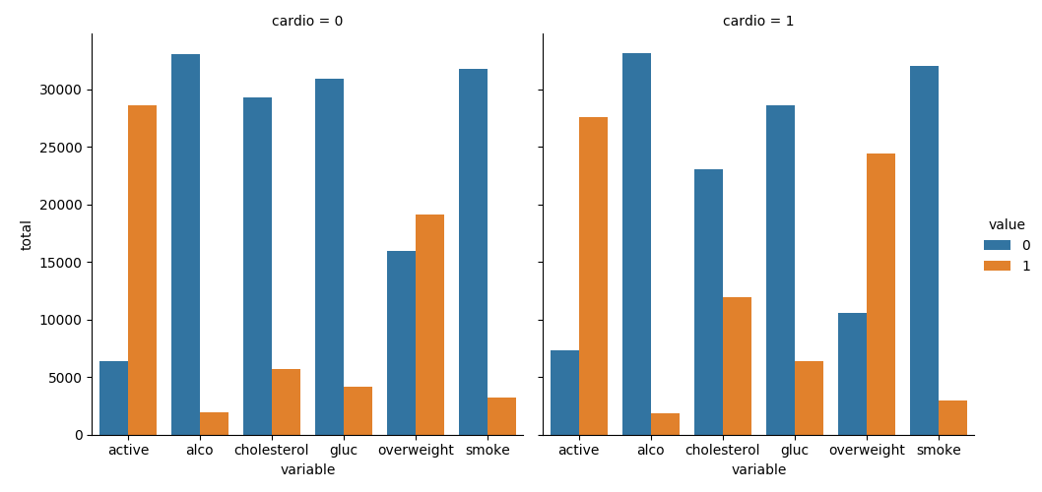

***Fig 2. Cardio***

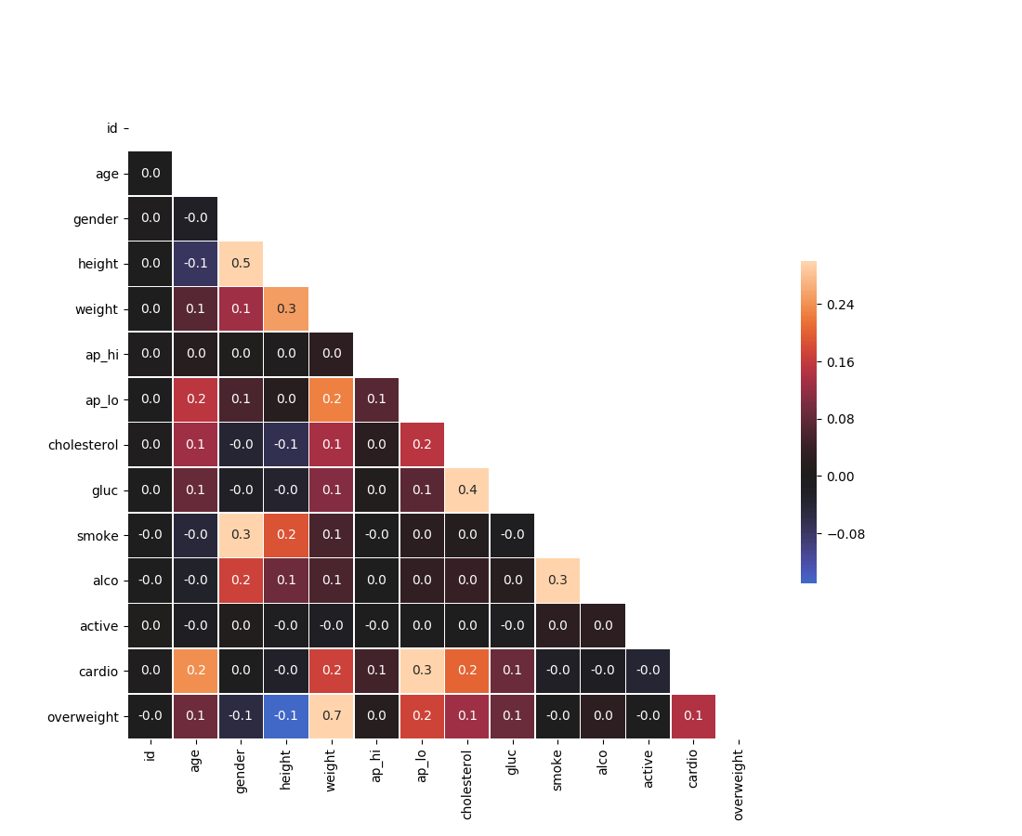

***Fig 3. Summary***

**CHAPTER 7**

***7.1 Conclusion***

Through a comprehensive methodology encompassing data collection, preprocessing, model development, and deployment, the project has laid the groundwork for more efficient and effective healthcare delivery. By automating manual processes, leveraging predictive analytics models, and generating actionable insights from healthcare data, the project aims to improve patient care, streamline operations, and enhance overall efficiency in healthcare institutions.

The integration of Python programming, AI algorithms, and cloud computing resources has enabled healthcare providers to extract valuable insights from vast and complex medical datasets. By developing predictive models and decision support systems, the project empowers clinicians with data-driven tools to make informed decisions, optimize treatment plans, and proactively address patient needs.

In summary, this project represents a significant advancement in healthcare informatics, with the potential to improve the well-being of individuals within Medicare and beyond. By leveraging technology and data analytics, we can transform healthcare delivery, enhance patient care, and ultimately, improve the quality of life for millions of people around the world.

**References**

1. Healthcare AI: <https://healthcareai.com/>
2. Healthcare Innovation: <https://www.healthcare-innovation.net/>
3. Health IT Analytics: <https://healthitanalytics.com/>